|  |  |
| --- | --- |
| Feature | Rank |
| Django support | postgresql > mysql > oracle >> mongodb |
| Popularity | oracle > mysql > postgresql > mongodb |
| Licensing & Open-source | postgresql >= mysql > mongodb >> oracle |
| Speed Optimization | postgresql > mysql |

**Postgresql vs. Mysql**

Postgresql has more advanced features. It has the best open source community and seems to be the top innovator in relational databases.

Mysql is slightly lacking in features compared to Postgresql, but has a larger userbase which can mean greater support.

Both databases support nosql with json, although Postgresql has had support for much longer. Speed between these 2 databases has historically been comparable.

Overall Postgresql seems to be the slightly better choice for startups. It is also easier to set up with django and has official support for python 3.

**Postgresql vs. Mongodb**

Postgresql has recently implemented JSON support so that it can compete with nosql databases, as well as still provide top-of-the-line relational queries. It is taking a hybrid approach to databases, providing solutions for those who need schemas and user/data relations, as well as random non-relational data mining.

Mongodb is best for data mining. It is used to store all data without worrying about what queries we need later. However, relational searches (ex. Finding data that belongs to a specific user) will be slower. This is the newest of all technology and as such there might be stability issues and unforeseen problems.

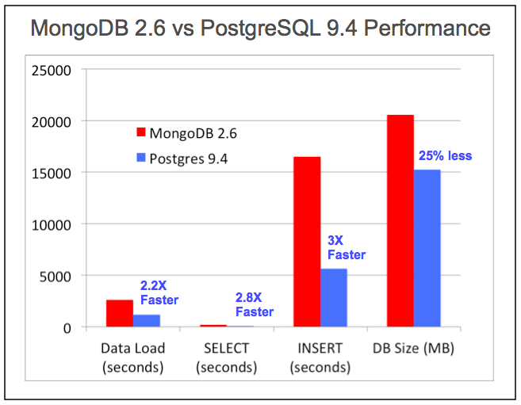

Source: EnterpriseDB White Paper: Using the NoSQL Capabilities in Postgres

(lower is better)

**Sources:**

[Official django database documentation](https://docs.djangoproject.com/en/1.10/ref/databases/)

[Database comparisons website](http://db-engines.com/en/system/MongoDB%3BMySQL%3BOracle%3BPostgreSQL)

[Question & answer about databases](https://www.quora.com/Which-database-should-I-use-for-a-killer-web-application-MongoDB-PostgreSQL-or-MySQL)

[A year of mongodb](https://speakerdeck.com/mitsuhiko/a-year-of-mongodb)

[Postgresql vs. MS SQL](http://www.pg-versus-ms.com/)

[Postgresql vs Mongodb](http://www.aptuz.com/blog/is-postgres-nosql-database-better-than-mongodb/)